**CATRING MANAGEMENT SYSTEM**

A Mini Project Report Submitted to

**SRI RAM NALLAMANI YADAVA COLLEGE OF ARTS ANDSCIENCE**

(Affiliated to Manonmaniam Sundaranar University)

In Partial fulfilment of the requirements of the award for the degree of

**BACHELOR OF COMPUTER APPLICATIONS**

**Done by**

SYED APPA HUSSAIN P 23081250500111026

SHEIK ABDULLA M 23081250500111024

YASAR M 23081250500111027

Under the Guidance of

**Mrs.A.IGNATIUSVIMALA,Msc.,MPhil.,**



**DEPARTMENT OF COMPUTER APPLICATIONS**

**SRI RAM NALLAMANI YADAVA COLLEGE OF ARTS AND SCIENCE TENKASI-627811**

**NOV-2025**

**CERTIFICATE**

This is to certify that the Major project entitled “**CATRING MANAGEMENT SYSTEM”** is a bonafied record of the project work done by **SYED APPA HUSSAIN, SHEIK ABDULLA, YASAR M** partial fulfilment of the **SRI RAM NALLAMANI YADAVA COLLEGE OF ARTS AND SCIENCE, TENKASI** during the 2022-2025. The project represents a group work on the candidates under my Guidance.

**HEAD OF THE DEPARTMENT INTERNAL GUIDE**

Submitted for viva-voice examination held at **SRI RAM NALLAMANI YADAVA COLLEGE OF ARTS AND SCIENCE, TENKASI** on __________

**EXTERNAL EXAMINER**

**1.**

**2.**

**DECLARATION**

We hereby declare that the mini project work “**CATRING MANAGEMENT SYSTEM**”is submitted to Manonmaniam Sundaranar University for the award of the degree of Bachelor of Computer Applications, of **SRI RAM NALLAMANI YADAVA COLLEGE OF ARTS AND SCIENCE,TENKASI**. The data and reports submitted are true and correct to the best of our knowledge

**Candidates**

1. **SYED APPA HUSSAIN P**
2. **SHEIK ABDULLA M**
3. **YASAR M**

**Internal Guide**

**Mrs.A.IGNATIUSVIMALA,Msc.,MPhil.,**

**ACKNOWLEDGEMENT**

First and foremost, we thank the almighty for showing his blessings on us to complete our project work in the most peaceful and efficient manner way.

We thank our correspondent **Dr.N.MANIMARAN,M.A.,M.Phil.,Ph.D** and secretary **Mrs.M.PADMAVATHY MANIMARAN,M.A.,M.Ed.,** of our college who directly and indirectly helped in us to do our course and complete this project.

And our principal **Dr.R.SANKAR,M.com.,M.phil.,Ph.D** of our college Sri Ram Nallamani Yadava College Of Arts and Science,Kodikurichi, for giving a chance to do this project work.

Our heartful thanks to **Dr..R.THIRUMALAISAMY.,MCA.,M.Phil.Ph.D.,**

Head of the Department Computer Applications, Sri Ram Nallamani Yadava College of Arts and Science,Kodikurichi, or giving this opportunity to work on this project and supporting us with his valuable suggestions.

We are greatful thanks to our guide **Mrs.IGNATIUS VIMALA Msc.,M.Phil.,,**For supporting with his valuable suggestions. Our deep sense of graditude to all the other faculty members of the Department of Computer Applications, Sri Ram Nallamani Yadava College of Arts and Science their timely help in completing the project work and also in our all academic activity.

|  |  |  |
| --- | --- | --- |
| CONTENTS | | |
| **S.NO** | **DESCRIPTION** | **PAGE NO** |
| 1. | Introduction |  |
| **2.** | system Analysis  Existing system  Proposed system  Feasibility study |  |
| **3.** | System Design  Flow Diagrams  Entity Relationship Diagram |  |
|  |  |  |
|  |  |  |
|  |  |  |

**ABSTRACT**

The Catering Service Management System is designed to make it easy for customers to book catering services from anywhere. This web application gathers all required information from the customer through online forms. Once registered, a customer can browse catering packages, view available dates, and book catering services for their events such as weddings, parties, or corporate functions. With this online platform, customers can view menus, register their event details, and confirm their bookings without visiting the catering office in person. Currently, most catering bookings are managed manually, making it difficult and time-consuming to keep track of menu options,and confirmed events. Searching for available slots or managing customer details takes much longer and increases the chance of mistakes. The aim of this project is to automate all major activities in catering management: recording menu options, available services, booking charges, and storing customer records in a central place. This catering management system makes the entire process quicker, more reliable, and accessible for both the catering business and its customers. Administrators can check booking records and customer information online at any time. The system provides a complete solution for all day-to-day catering office activities, from booking management and event scheduling to real-time availability and customer communications. Based on the data and reporting features, business owners can make better decisions for future development and growth.

**CHAPTER I**

**INTRODUCTION**

Catering Service Management System is a comprehensive web-based platform designed to simplify the catering order process for both customers and administrators. The system provides a streamlined interface, allowing customers to easily browse a variety of catering menus and packages, book their preferred options for any event, and manage all bookings with ease.

Customers can explore menu options based on filters such as cuisine, service type, price, and availability. Once a package is selected, users can book catering for specific dates, enter event details,and receive instant confirmation. The system ensures maximum user convenience by enabling booking management, order history review, and customer detail updates at any time. Meanwhile, administrators have access to powerful tools to track bookings, answer customer inquiries, update menu offerings,. The platform is designed to maximize operational efficiency, eliminate manual errors, and provide customers with a smooth, error-free booking experience.

**The Motivation to create this project has many sources**

* The project aims to provide a seamless and efficient catering service platform, addressing the complications customers face in manually booking and tracking event orders.
* The platform offers a smooth online booking experience that enables customers to reserve catering services from anywhere at any time.
* The creation of this system is motivated by a need to enhance customer convenience, customer registration and menu browsing.

## Project Overview Background

In real-world scenarios, organizing catering for events such as weddings, parties, or corporate meetings can be challenging. Manual booking systems make it difficult to track event dates, menu choices, and customer information. Often, customers or event organizers must call, email, or visit caterers to check availability and place orders, which increases the possibility of scheduling conflicts, lost information, and delayed confirmations. The Catering Service Management System addresses these issues by digitizing the process: the platform allows customers to

1

register once and book multiple events quickly. Users simply provide essential details—such as event type, guest number, preferred menu, and date—which are

stored securely and efficiently in the system. Customers may also review their past bookings, supporting continuous service improvement. For catering businesses, the system enables better planning, staff scheduling, and stock management, increasing retention and enhancing the quality of service.

## The Modules used in this software are as follows :

## CUSTOMER REGISTRATION :

* Customers must provide their name, email, phone number, and password to register an account.
* These details are stored in the database for login and booking.

## EVENT ORGANIZER REGISTRATION :

* Event organizers register separately with organizer name, email, phone number, and password.
* This allows organizers to manage menu offerings and view bookings.

## LOGIN :

* Both customers and organizers can log in using their registered email and password. Role-based login restricts access to respective dashboards.

## BOOKING :

* Customers can view available menus and packages.
* When booking, the system asks for details like event address, event date, event type, number of people, and selected menu/package.
* Booking info (including all required details) is stored for review and management by both customer and organizer.
* No online payment is included; booking status is managed by the organizer (Accept/Cancel).

2

## BOOKING MANAGEMENT :

* Customers can view booking status and history.
* Organizers can view upcoming bookings and update their status (Pending, Completed, Cancelled).

2

## PRODUCT (SESSION) MANAGEMENT :

* Both users and organizers can log out after completing their session.

## Non-Functional Requirements of Catering Management System

## 

## Non-functional requirements refer to system qualities such as security, reliability, response time, and usability, which define constraints rather than direct functionality. These requirements ensure the system remains robust, secure, and user-friendly throughout usage by customers and event organizers. They are planned in the system architecture and design, and help support all core and extended catering management functionality. The requirements are grouped as follows:

## SECURITY :

* Only registered users can access their own information securely with email and password login.
* User data, including booking and personal details, is protected and stored securely.
* All communication with the system is encrypted to prevent unauthorized data access or breaches.

**RELIABILITY:**

* The system consistently performs its intended functions without failure during usage.
* Data stored in the system is safe, secure, and available whenever needed.
* Users can trust the system to provide accurate booking and service information at all times.

3

**CHAPTER II**

**SYSTEM ANALYSIS**

**DEFINITION**

System Analysis is a detailed study of the different operations performed by the system and how they interact internally and externally. Analysis helps break down each task and understand the workflow thoroughly. System analysis identifies all key problems, relevant variables, and decision points in the catering management process. It is about evaluating current workflows, examining problems, and then recommending new solutions and resource allocations for building an improved catering service system.

**EXISTING SYSTEM:**

The current system for many catering businesses is a manual, paper-based process. Manual management is time-consuming, error-prone, and often causes confusion for both customers and event organizers. Catering managers and customers communicate through calls or visits; menu planning, booking, and scheduling is tracked with paperwork or spreadsheets. This leads to lost bookings, missed updates, and reduced efficiency.

* Customers must contact the caterer personally to make a booking.
* There is no user-friendly online platform for checking menus, availability, or booking events.
* Menu selection, guest numbers, and event details are collected manually.
* Bookings and schedules are tracked by hand, making them prone to mistakes.
* It is challenging for event organizers to quickly verify upcoming bookings and manage resources.

**PROPOSED SYSTEM:**

The proposed Catering Service Management System is built to fix these drawbacks by providing a digital, online solution. The system offers a single platform where customers can register, browse menus, check date availability, and make bookings easily. Event organizers can see all bookings in real-time, update availability, and manage their menus, all from an online dashboard. The main aim is

4

to increase efficiency, accuracy, and productivity for both customers and catering businesses while reducing manual workload and minimizing errors.

* The user can log in to the system and check for available catering event slots and menu packages.
* The user must specify event date, event time, number of guests, and meal preferences.
* This tool enables the user to book catering services for their special occasion.
* The system checks date and slot availability and confirms with the customer.
* All the data regarding bookings, customers, and services are stored in a MySQL database.
* The user must enter their name, event address, phone details, and event info while booking.
* The system is developed using modern web technologies for reliability and usability

**FEASIBLITY STUDY :**

1. Technical Feasibility

**Frontend:**

* **HTML,CSS:** Used for building responsive layouts and styling the web application.
* **JavaScript:** Enables client-side logic, interactive behaviors, and dynamic form validation.
* **React JS:** Framework for building component-based, modern user interfaces (UIs) that make the application dynamic, fast, and user-friendly.

**Backend:**

* **Java:** The primary programming language used for backend development, offering portability, reliability, and strong support for enterprise-scale applications.
* **Spring Boot**: A modern, easy-to-use Java framework for building REST APIs and server-side logic. Handles user registration, authentication, booking management, and all business rules in your catering platform.

5

* **MySQL:** A popular relational database for storing customer information, event bookings, menu data, and all other structured records. Integrates smoothly with Spring Boot for secure and reliable data operations.

6

**CHAPTER III**

**SYSTEM SPECIFICATION**

**HARDWARE REQUIREMENTS :**

Processor : Intel(R) Core(TM) i3-8130U

Processor Speed : 2.20GHz

RAM : 4 GB

Hard Disk : 40GB to 80GB

**SOFTWARE REQUIREMENTS :**

Database : MySQL

Backend : Java, Spring Boot

Frontend : HTML, CSS, JavaScript, React JS

Operating System : Windows 11 (or any OS supporting Java&Node.js)

**SOFTWARE DESCRIPTION LANGUAGE USED**

**1.HTML**

* Hypertext Markup Language (HTML) is used to structure all user interface pages displayed in the browser.
* HTML forms the skeleton for all screens (registration, menus, booking forms, etc.).
* Together with CSS and React JS, it enables a dynamic and responsive platform for both customers and event organizers.

**2.CSS**

* Cascading Style Sheets (CSS) is used to define the look and design of all pages in the catering platform, such as layout, color schemes, and font styles. CSS works alongside HTML and React JS to separate presentation (design) from content (data).

7

* Defining styles in .css files allows the team to quickly update the visual appearance of menu listings, forms, and event calendars without changing the core content or code structure. This separation improves usability and accessibility for customers and event organizers on any device.
* In this project, styles are organized as component-based CSS (using CSS modules with React) so each frontend feature—such as the booking form or menu display—can have unique, reusable/collapsible styles with minimum code repetition.

**3.JAVASCRIPT**

* JavaScript is used for adding interactivity and dynamic features to the front end. All logic for client-side validation, real-time availability checking, dynamic menu loading, and responsive navigation (like pop-ups and confirmation dialogs) is built using JavaScript.
* In this project, modern JavaScript (ES6+) is used together with React JS for clear code organization, efficient UI updates, and better development experience. Plain (Vanilla) JavaScript and React enable features like calendar selection, instant feedback, and seamless user journeys—for both customers and event organizers—without any extra frameworks.
* JavaScript code interacts with the backend APIs (built with Spring Boot Java), sending and receiving data such as user registration, bookings, and menu details, making the catering platform completely dynamic and interactive.

**4.REACT JS**

* React JS is a modern JavaScript library used for building advanced user interface in web applications. In this catring project, React JS powers all frontend screens, enabling smooth, dynamic, and highly interactive user experiences for both customers and event organizers.
* React helps break the website into reusable components (like menu sections, booking forms, login pages), making development and maintenance faster and more organized.
* Using React’s state management and virtual DOM, the application can quickly update parts of the UI (for example, available booking slots or menus) without reloading the whole page, resulting in a fast and seamless experience.

8

**5.JAVA**

* Java is a robust, object-oriented programming language used to build the backend logic for the catering management platform.
* It powers all business processes like registration, login, reservation handling, and data validation.
* Java provides secure, cross-platform support for developing reliable and scalable APIs, serving as the foundation for Spring Boot microservices in your project.

**6.SPRING BOOT**

* Spring Boot is a modern Java framework that simplifies the development of web applications and REST APIs.
* In this project, Spring Boot manages all backend services: connecting to MySQL, processing bookings, and handling customer/organizer interactions.
* It enables fast and secure connections between the React frontend and database, with built-in tools for validation, authentication, and deployment.

**7.MYSQL**

* MySQL is an open-source relational database used to securely store all project data, including user details, event bookings, menu information, and feedback.
* It enables fast, reliable, and structured access to data, supporting the needs of both customers and event organizers through efficient queries.
* MySQL integrates seamlessly with Java Spring Boot, ensuring smooth data flow between the backend and the application—making the catering

## 8. SYSTEM DEPLOYMENT & REQUIREMENTS

* The application is deployed on a local or cloud server that supports Java (for Spring Boot backend) and Node.js (for building React JS frontend).
* The browser-based frontend works on all modern browsers (Chrome, Firefox, Edge, etc.), accessible from desktop, laptop, mobile, and tablet devices.
* MySQL database server stores all data securely and can be managed with standard tools (MySQL Workbench, or command line).

9

**CHAPTER IV**

**SYSTEM DESIGN**

In this catering platform, the design phase is essential to define all functionalities needed for seamless user experience—such as customer/organizer registration, service listing, menu management, and order booking. Once the requirements have been gathered (like customer sign-up, event organizer profiles, menu uploads, booking, and billing), the design phase involves technical activities

**ER DIAGRAM :**

* The ER diagram for our catering platform project visually maps the core system modules and their relationships, making database design clear and organized. At the center of the diagram are the main entities such as Customer, Event Organizer, Menu, Booking, and Service, each depicted as a rectangle with their key attributes connected as ovals. helping both developers and stakeholders to understand the flow of information within the system. By following the ER diagram, the logical structure of the catering application's database becomes easy to visualize, develop, and maintain, supporting smooth registration, order management, and service listing features throughout the platform.

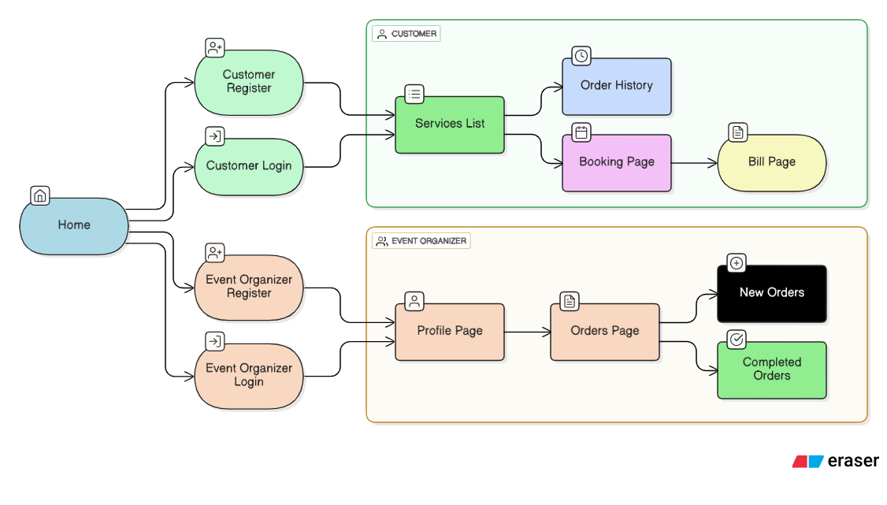

Figure :ER Diagram of Catring Management System

10

* The database schema for our catering services application defines the structural design and logical organization of all stored data. This schema provides a complete description of how information is managed within the system. It includes entities such as Customer, Event Organizer, Menu, Booking, and Service, each with their own set of defining attributes. The schema diagram visually represents these entities in the form of tables and clearly maps out relationships—such as customers making bookings, organizers managing menus, and bookings recording event and menu details. This diagram only describes how the data is structured; it does not contain the actual data itself. By representing the connections and attribute details between the various tables, the schema diagram ensures that the data is reliable, easily accessible, and efficiently organized to support every function of the catering platform.

11

**SCHEMA DIAGRAM :**

In our catering platform, the database schema is structured to represent all the main application modules and their data relationships. The schema includes multiple tables—such as Customer, Event Organizer, Menu, Booking, and Service—each containing columns to store attributes relevant to the corresponding entity. For instance, the Customer table holds details like name, email, and address, while the Menu table records dish names, descriptions, and prices linked to organizers. The schema defines how these different tables are interconnected: customers place bookings, event organizers manage menus and services, and bookings keep track of order details, menu choices, and customer information. This schema diagram serves as a blueprint for our entire database, clarifying how every piece of information is stored and ensuring robust, organized data management for the catering application

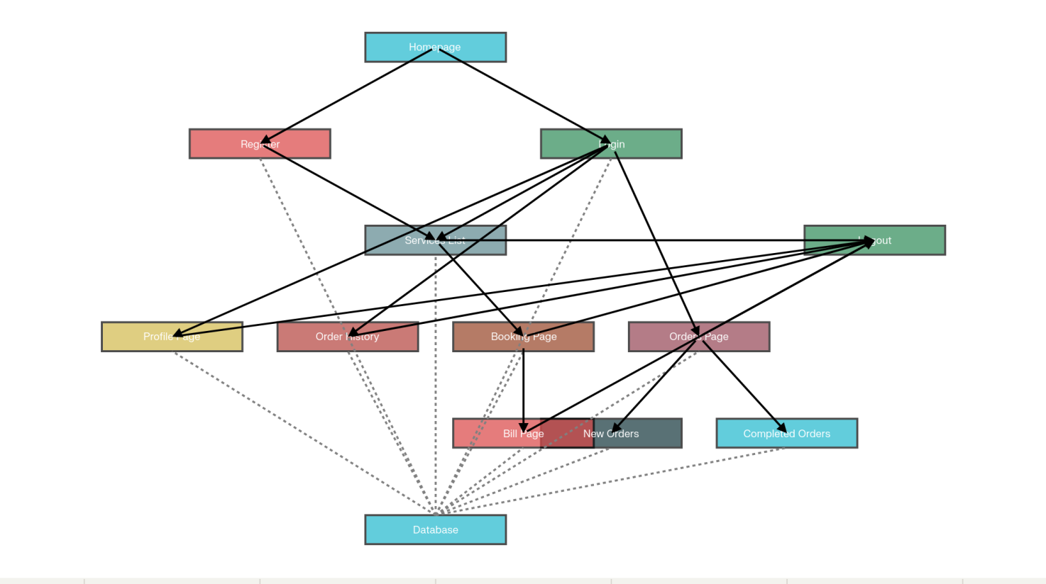

Figure : Schema Diagram of Catring Management System

12

**BLOCK DIAGRAM :**

* A block diagram for the catering services platform represents the main functional components and their interactions as discrete blocks connected by lines indicating data and control flow. It provides a high-level overview of how different modules—such as User Registration, Login, Services List, Booking, Order History, and Billing—interact with each other and the central database.

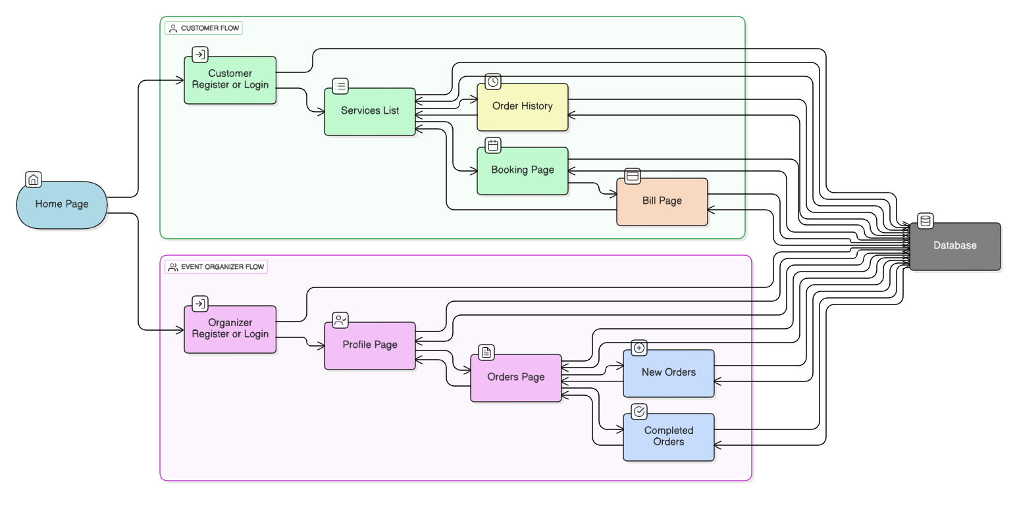

Figure : Block Diagram of Catring Management System

* In the figure, both customers and event organizers register by providing their account details, which are securely stored in the database. During login, the platform verifies the submitted credentials against stored records. Once authenticated, users are allowed to access and perform workflow operations based on their roles. Customers can browse available catering services, view their order history, make new bookings, and process payments for their orders—all data actions involving retrieval or updates in the database. Event organizers manage their profile, access new and completed bookings, and update their offered services and menu details directly via the platform, with these changes reflected in the database. At the completion of tasks, users can securely log out. All information remains available in the database for seamless access and continued service during future logins, ensuring a consistent experience across the platform.

13

**FLOWCHART :**

* In the catering platform’s flowchart, the process starts with customers or event organizers deciding whether to register or log in. Registration and login steps involve providing and verifying user details, all of which are managed in the system database. After authentication, customers can browse available catering services, view menus, and proceed to the booking process by selecting their desired services and entering event details. The system allows customers to view their order history and generate bills for their completed bookings, with every step updating the backend database in real time. Event organizers, once authenticated, can update their service information, manage menu offerings, and monitor new and completed orders. At any point, users can choose to log out; all their details and actions are saved, ensuring a seamless experience upon their next visit to the catering portal. This flowchart helps visualize every step, conditional branch, and operation for both customers and event organizers in the application

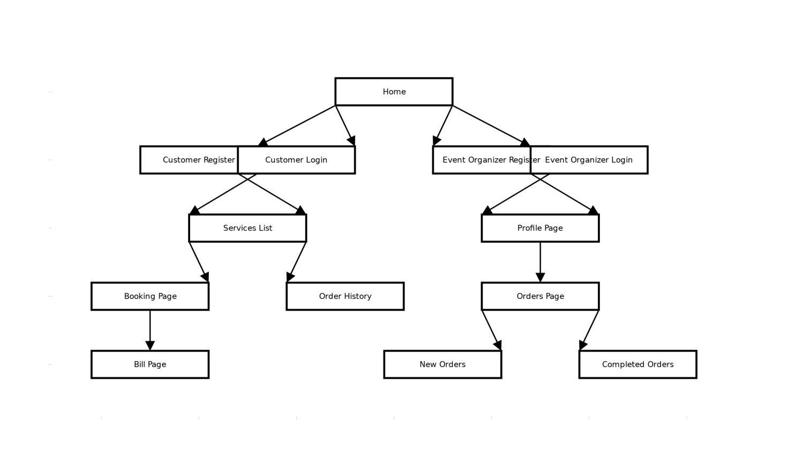

Figure : Flow Chart of Catring Management System

14

**DESCRIPTION OF TABLES :**

**The database consists of four tables:**

**Booking :**

| **S.No** | **Column Name** | **Data Type** | **Constraints** |
| --- | --- | --- | --- |
| 1 | id | INT | Primary Key, NOT NULL, UNIQUE |
| 2 | advance_amount | DECIMAL(10,2) | NOT NULL, CHECK (>=0) |
| 3 | booking_date | DATE | NOT NULL |
| 4 | caterer_email | VARCHAR(255) | NOT NULL, FOREIGN KEY (Caterer) |
| 5 | customer_address | VARCHAR(255) | NOT NULL |
| 6 | customer_email | VARCHAR(255) | NOT NULL, FOREIGN KEY (Customer) |
| 7 | customer_location | VARCHAR(255) |  |
| 8 | customer_mobile | VARCHAR(20) | NOT NULL |
| 9 | customer_name | VARCHAR(100) | NOT NULL |
| 10 | meal_times | VARCHAR(50) | NOT NULL, CHECK (Valid meal slots) |
| 11 | number_of_people | INT | NOT NULL, CHECK (>0) |
|  |  |  |  |
| 12 | plate_rate | DECIMAL(10,2) | NOT NULL, CHECK (>=0) |
|  |  |  |  |
| 13 | status | VARCHAR(50) | NOT NULL, DEFAULT ('Pending') |
| 14 | total_amount | DECIMAL(10,2) | NOT NULL, CHECK (>=0) |

15

**Admin :**

| **S.No** | **Column name** | **Datatype** | **Constraints** |
| --- | --- | --- | --- |
| 1 | ADMIN_ID | Varchar2(255) | Primary key |
| 2 | ADMIN_PASSWORD | Varchar2(255) |  |

**EventOrganizer:**

| **S.No** | **Column Name** | **Data Type** | **Constraints** |
| --- | --- | --- | --- |
| 1 | id | INT | Primary Key, NOT NULL, UNIQUE |
| 2 | email | VARCHAR(255) | NOT NULL, UNIQUE |
| 3 | food_type | VARCHAR(20) | NOT NULL |
| 4 | location | VARCHAR(100) | NOT NULL |
| 5 | max_people | INT | NOT NULL, CHECK (>0) |
| 6 | menu | VARCHAR(1000) | NOT NULL |
| 7 | min_people | INT | NOT NULL, CHECK (>0) |
| 8 | mobile | VARCHAR(20) | NOT NULL, UNIQUE |
| 9 | name | VARCHAR(100) | NOT NULL |
| 10 | password | VARCHAR(50) | NOT NULL |
| 11 | plate_rate | INT | NOT NULL, CHECK (>=0) |
| 12 | profile_photo | VARCHAR(255) |  |
| 13 | service_name | VARCHAR(255) | NOT NULL, UNIQUE |

16

**Customer:**

| **S.No** | **Column Name** | **Data Type** | **Constraints** |
| --- | --- | --- | --- |
| 1 | id | INT | Primary Key, NOT NULL, UNIQUE |
| 2 | email | VARCHAR(255) | NOT NULL, UNIQUE |
| 3 | mobile | VARCHAR(20) | NOT NULL, UNIQUE |
| 4 | name | VARCHAR(100) | NOT NULL |
| 5 | password | VARCHAR(50) | NOT NULL |

17

**CHAPTER V**

**SYSTEM IMPLEMENTATION**

Implementation for the Catering Services Management System starts once the design and planning are complete and the initial version of the software has passed development testing. The main modules, such as customer registration, admin login, service provider (caterer) panel, menu listing, booking management, and order/payment processing, are deployed on the server and integrated with the MySQL database.

**User onboarding,**admin and service provider panels are tested for correct authentication and role-based access. Responsive React.js frontend is implemented for customer, caterer, and admin, ensuring proper user navigation and data flow between frontend and backend (built on Spring Boot). All API endpoints (for registration, login, menu management, order booking, etc.) are tested with Postman to validate that records are stored and fetched correctly from the database.

* **User education and training:**Admins, caterers, and customers are given user guides or walkthroughs demonstrating how to register, update details, view or manage bookings, and make or verify payments.
* **System testing:**Each module (customer, admin, and caterer) is tested separately as well as in integrated flow. Test cases check for correct data validation, prevention of duplicate records, and appropriate error handling in the UI.

Hardware and software requirements include a system running a Java JDK, Node.js for frontend, MySQL database, and a web server (such as XAMPP or Tomcat). After all modules are tested and validated, users are able to register, log in, search menus, book catering services, and receive booking and payment notifications. Once verified, the project moves to deployment and ongoing maintenance.

**System Testing**

**Software Testing Strategies :**

Testing in this catering services project followed a well-structured strategy aligned with each feature and user role. All modules—such as registration, login, menu display, booking, payments, and admin controls—were planned for comprehensive verification using both manual and automated test cases. The goal was to confirm reliable data flow between the React frontend, Spring Boot backend, and MySQL database

18

## Types of Testing Applied

## There are different types of testing. They are:

## Unit Testing

## Integration Testing

## White Testing

## Usability Testing

## Performance Testing

## Compatibility Testing

## Unit Testing:

## Individual backend API endpoints (like customer registration, booking creation, menu fetch) were tested using Postman and JUnit to confirm proper input validation, status codes, and correct data storage in MySQL.

## Integration Testing:

## The combined working of frontend React components with backend REST APIs was validated, verifying that user input in the UI correctly triggered database updates and returned accurate information (e.g., bookings shown in user and admin dashboards).

## White Testing:

## Code-level checks ensured that service logic and controllers worked as intended, covering all authentication, filtering, and calculation scenarios.

## Usability:

## Real users and test users navigated the site on desktop, tablet, and mobile to check for clear instructions, responsive design, and ease of booking and data management.

## Performance Testing:

## Key actions like large menu uploads, bulk order bookings, and high-concurrency logins were simulated to ensure the system handled normal and peak loads efficiently.

## 19

## Compatibility Testing :

## The application was run on different browsers and devices to ensure consistent performance and correct visual layout everywhere.

20

**CHAPTER VI**

**SAMPLE OUTPUT**

**System Design :**

**1.Homepage :**

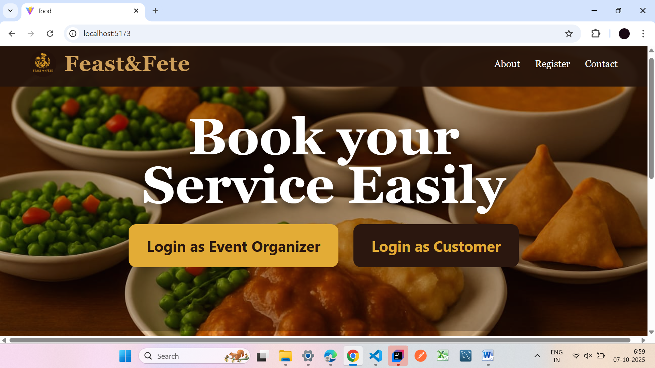

**2.Registerpage:**

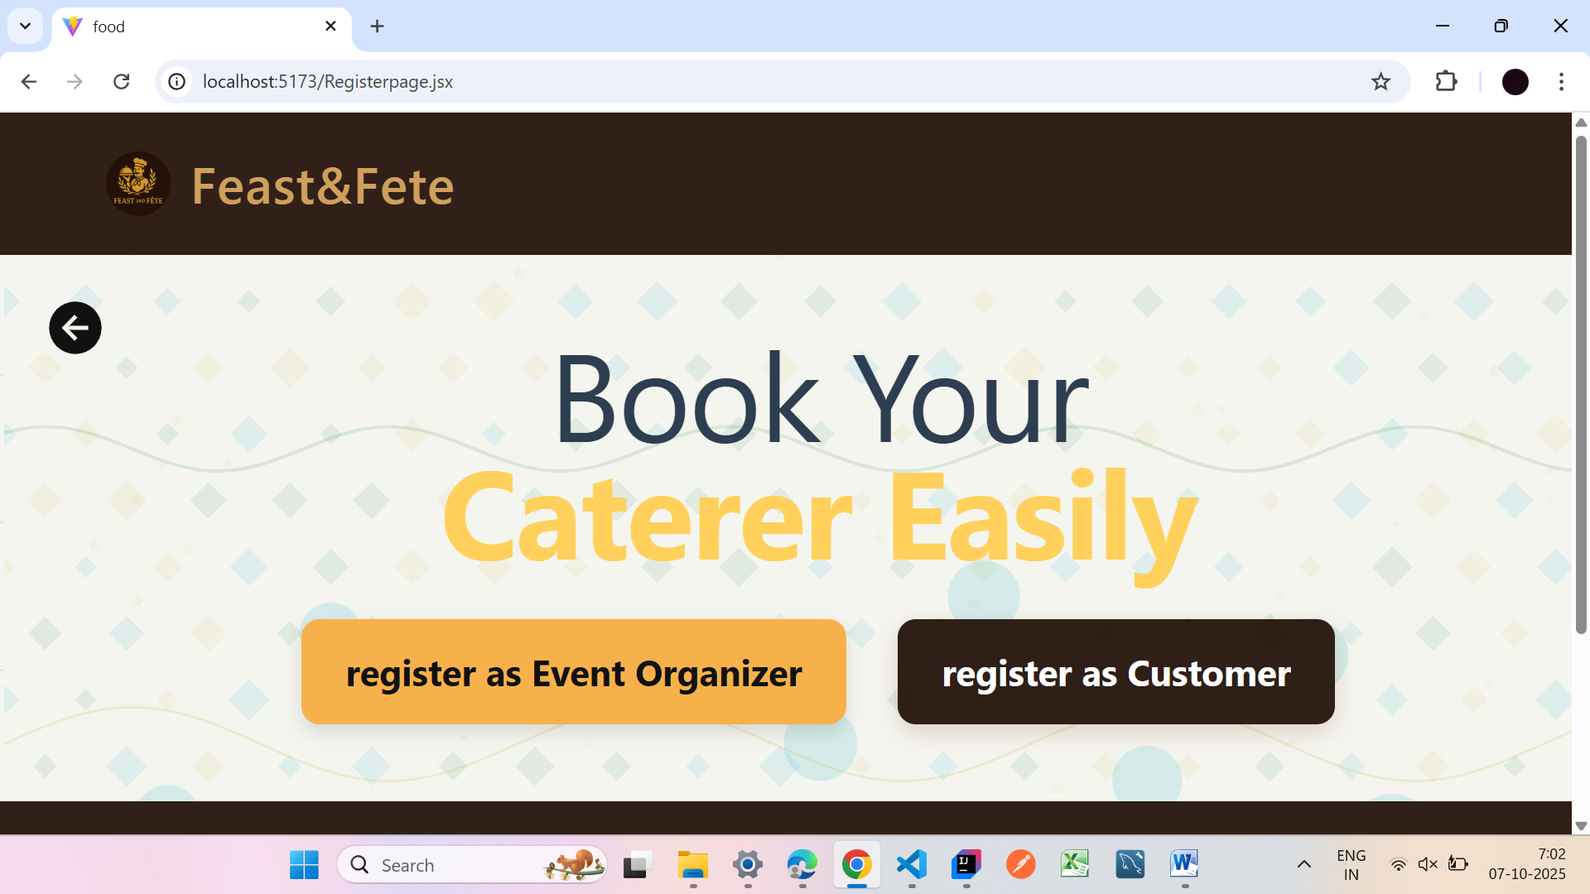

21

**3.EventOrganizer register page:**

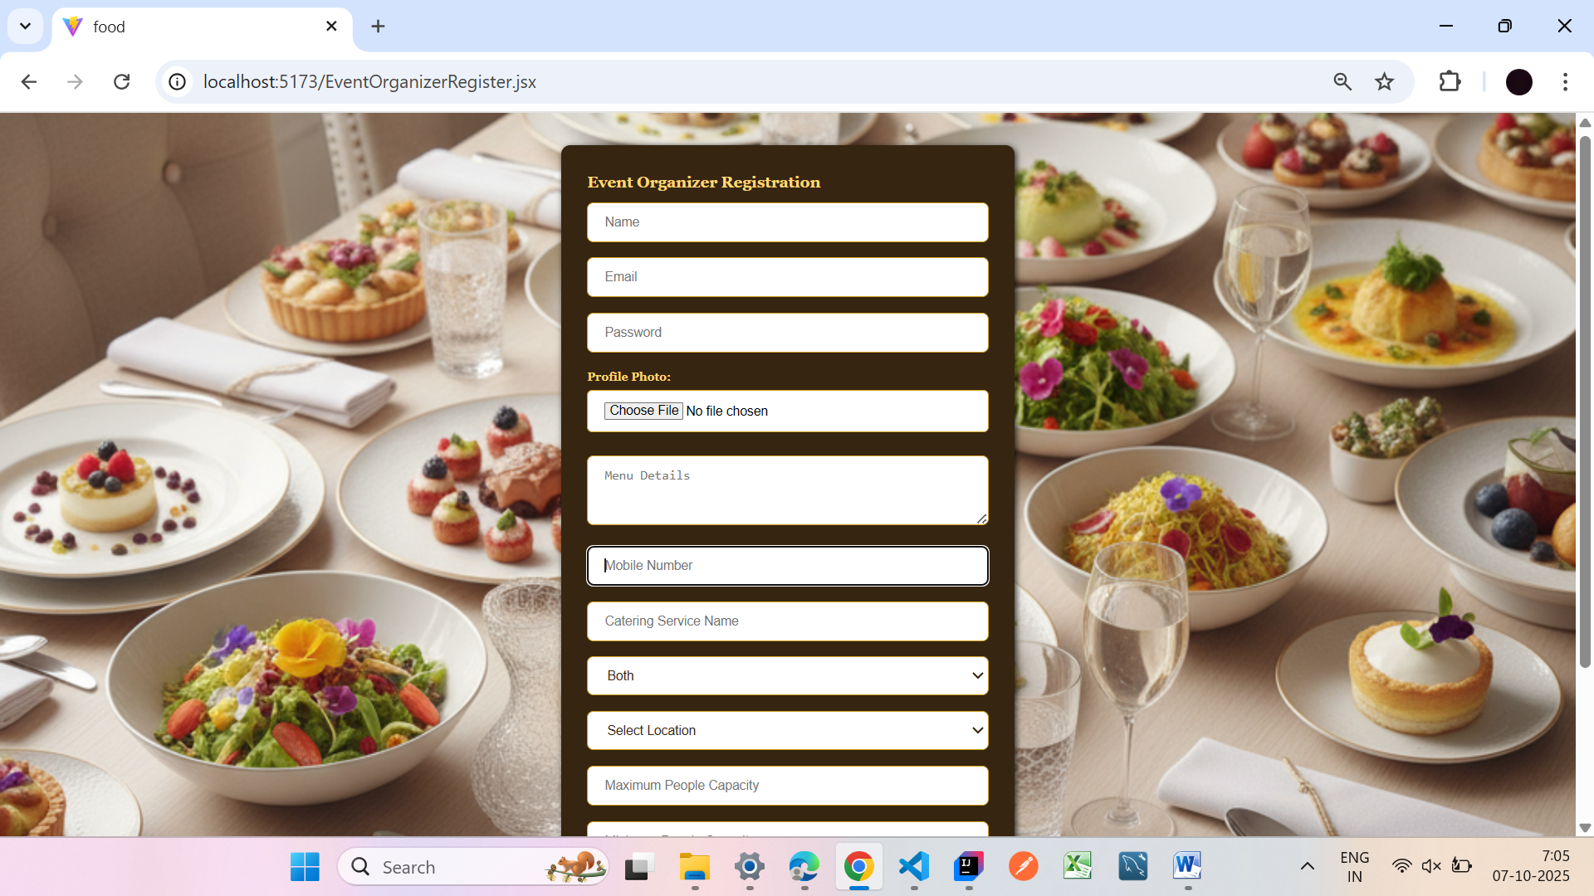

**4.EventOrganizer Profile:**

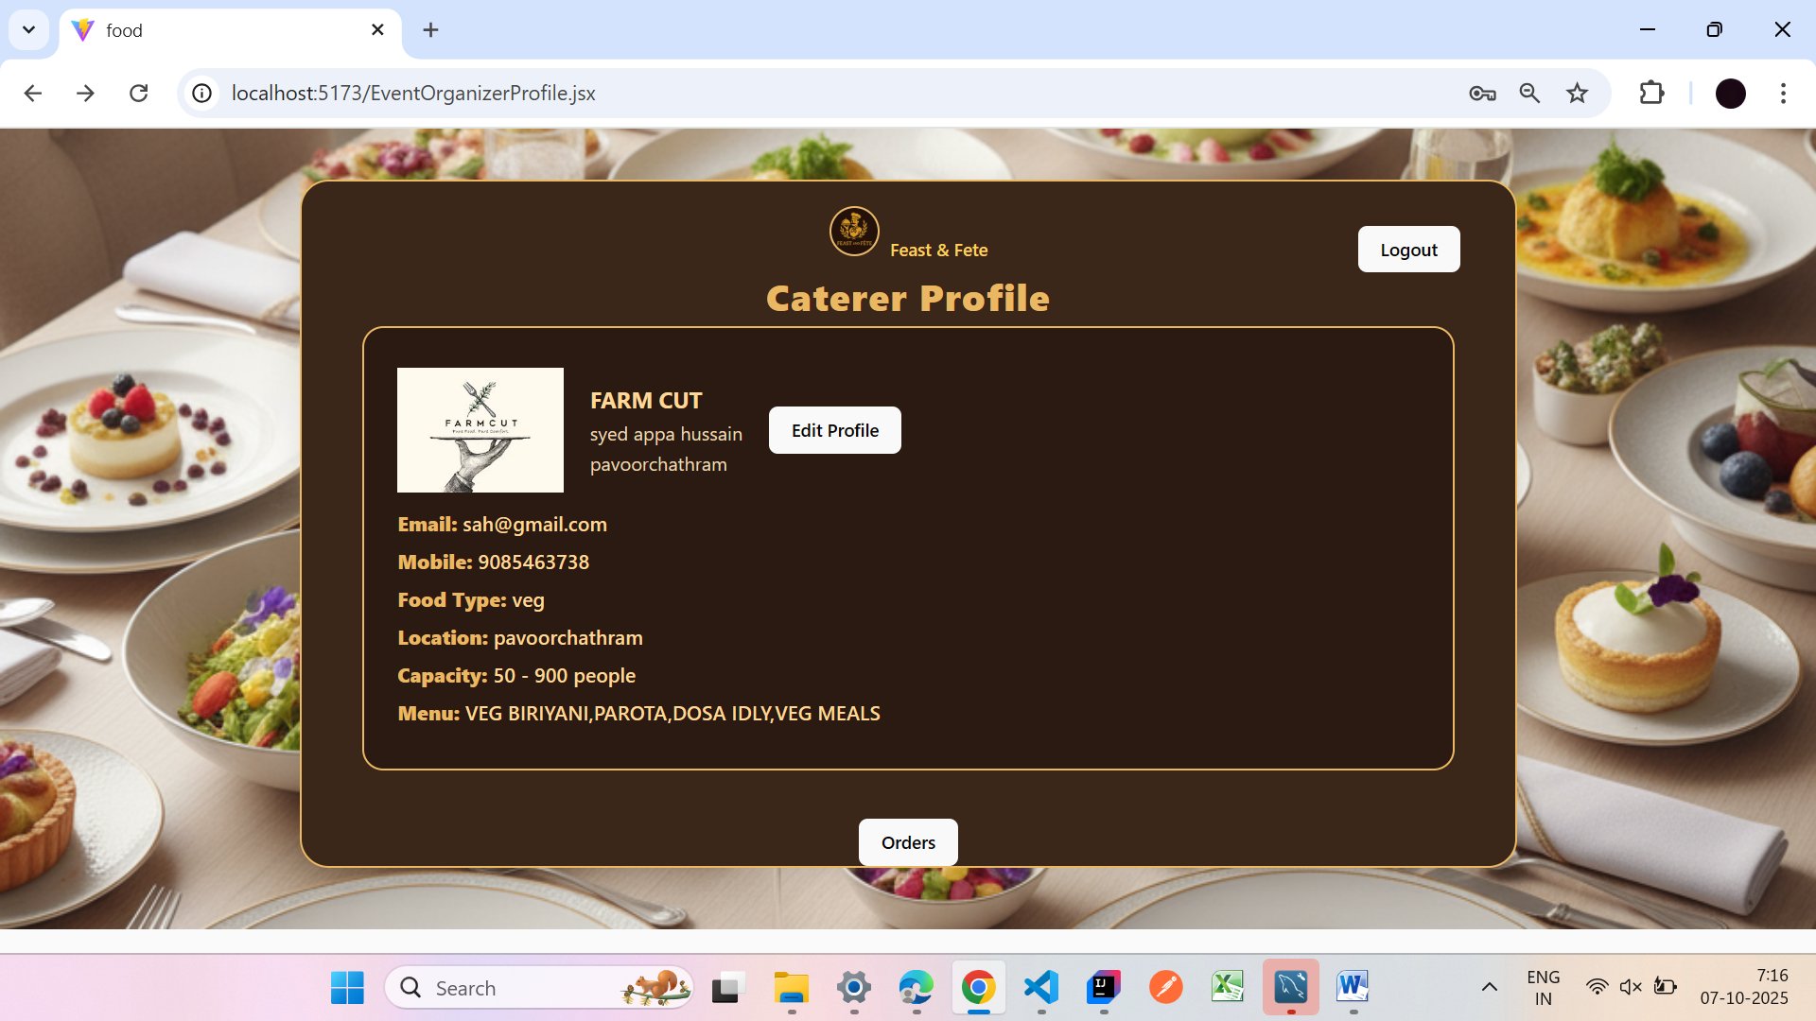

22

**5.ordersview page:**

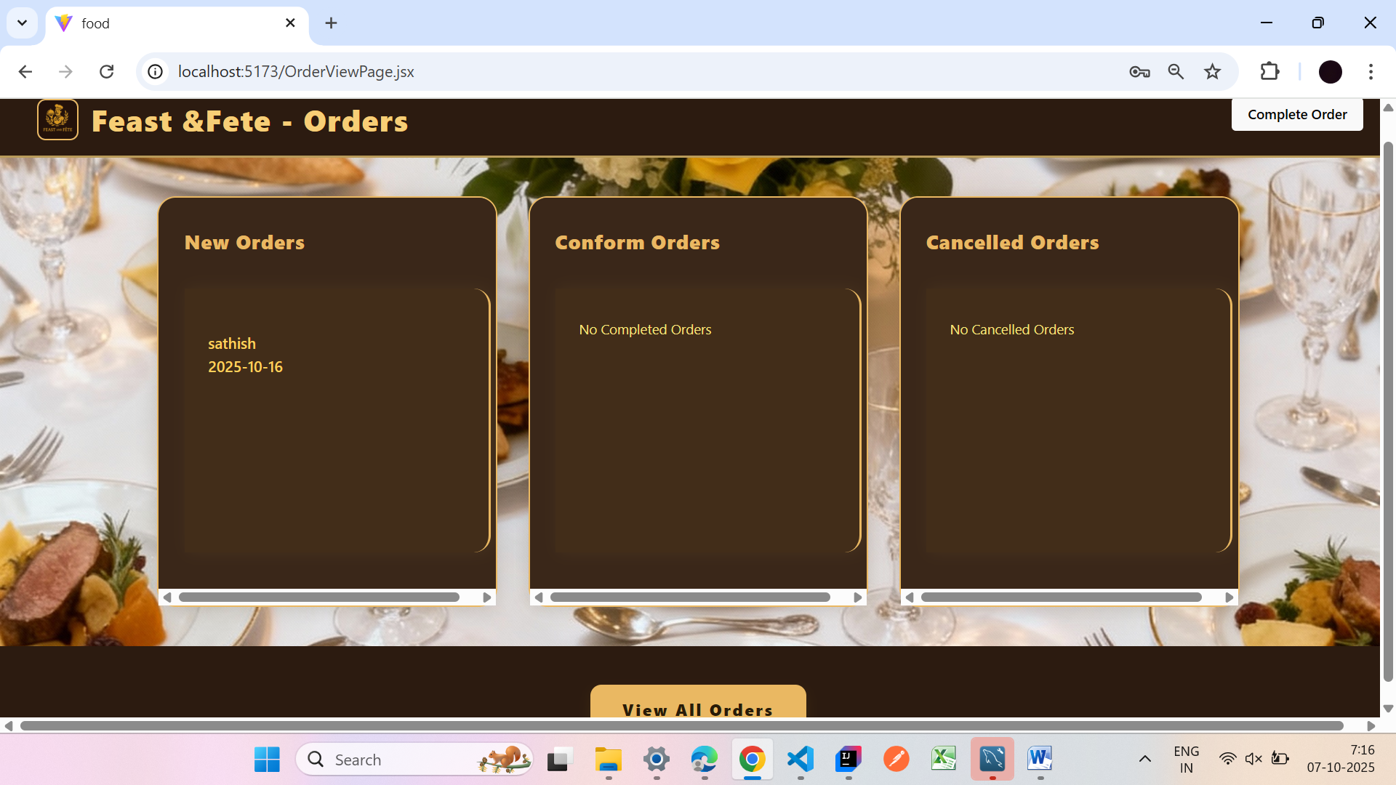

**6.New Orderspage:**

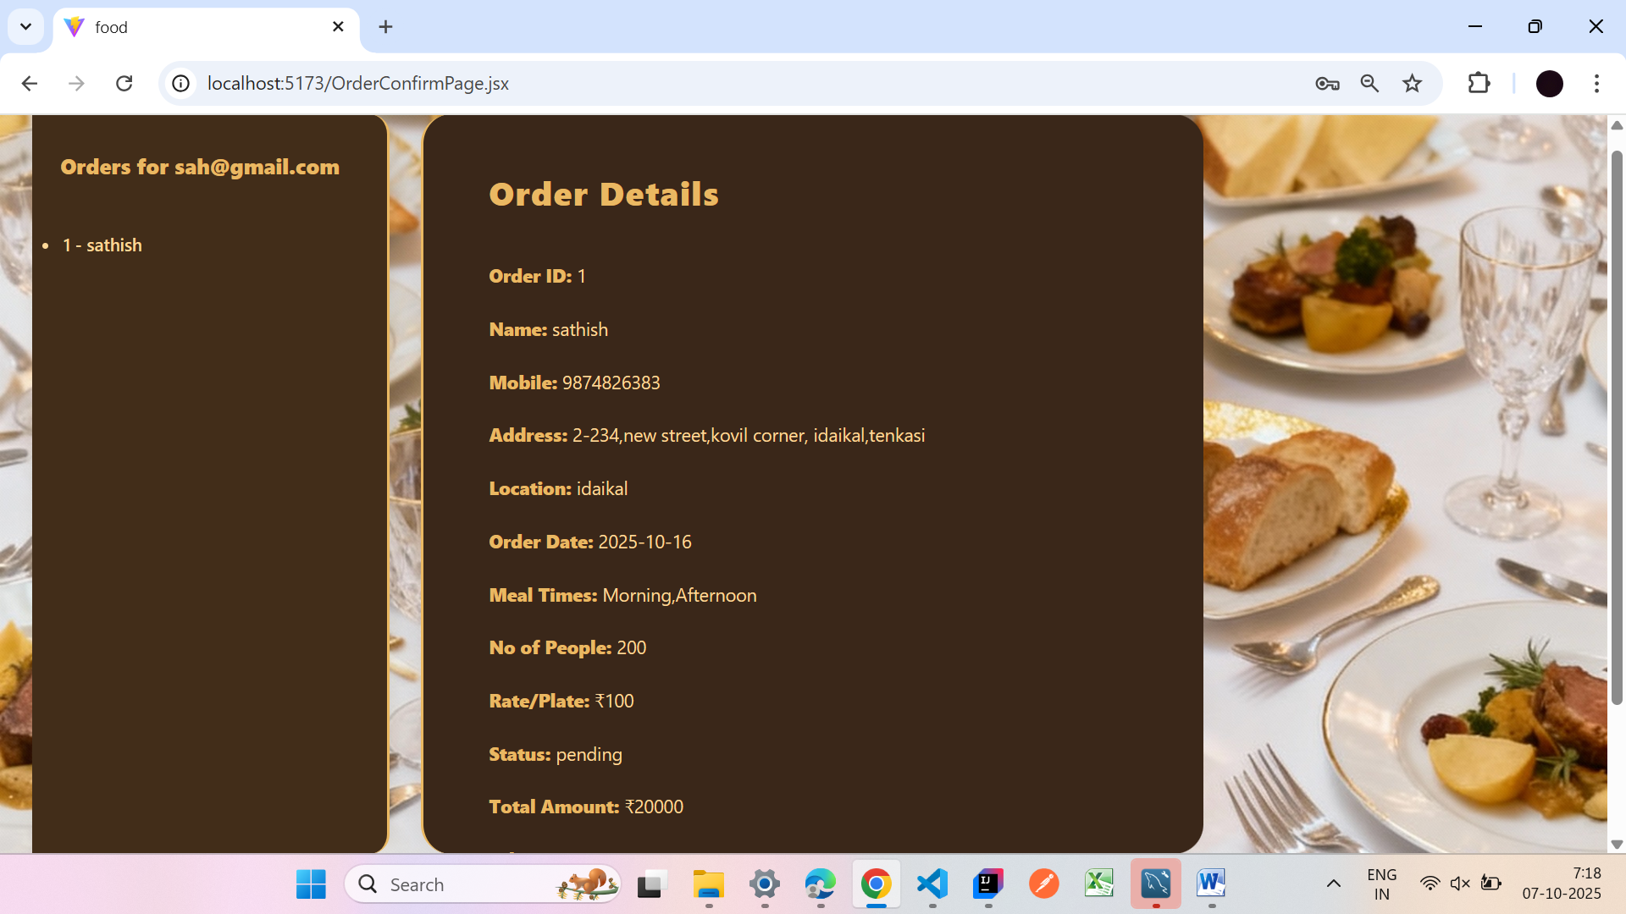

23

**7.Completed order page:**

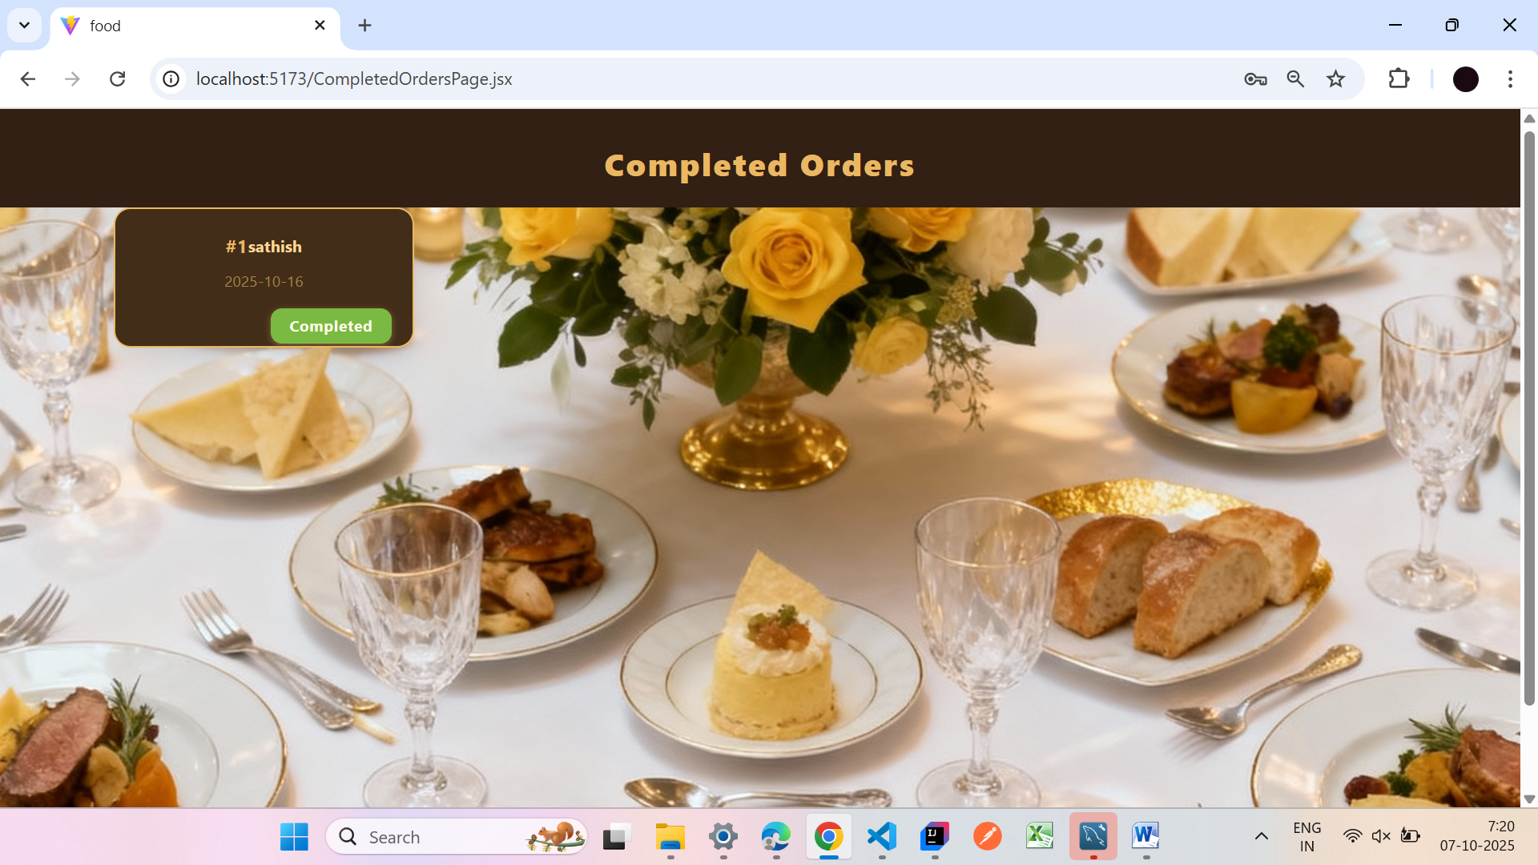

**8.Catring Services List:**

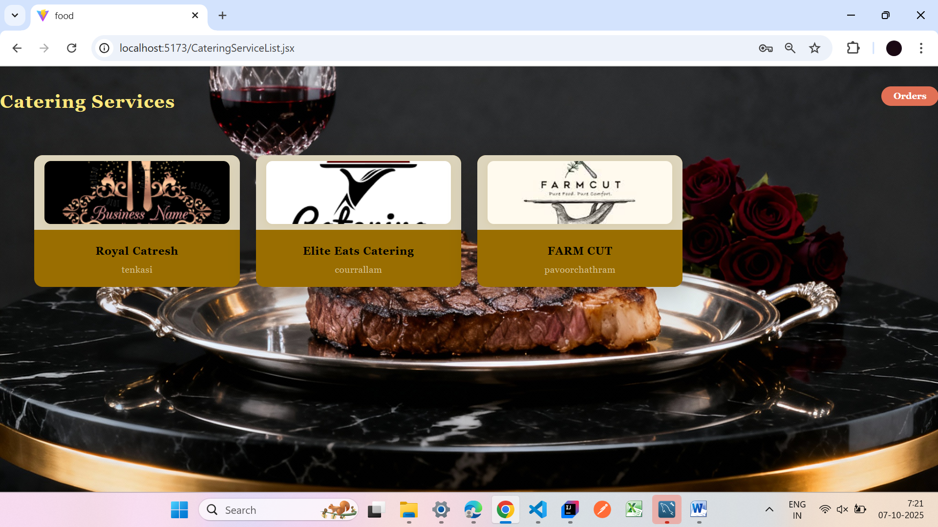

24

**9.BookingPage:**

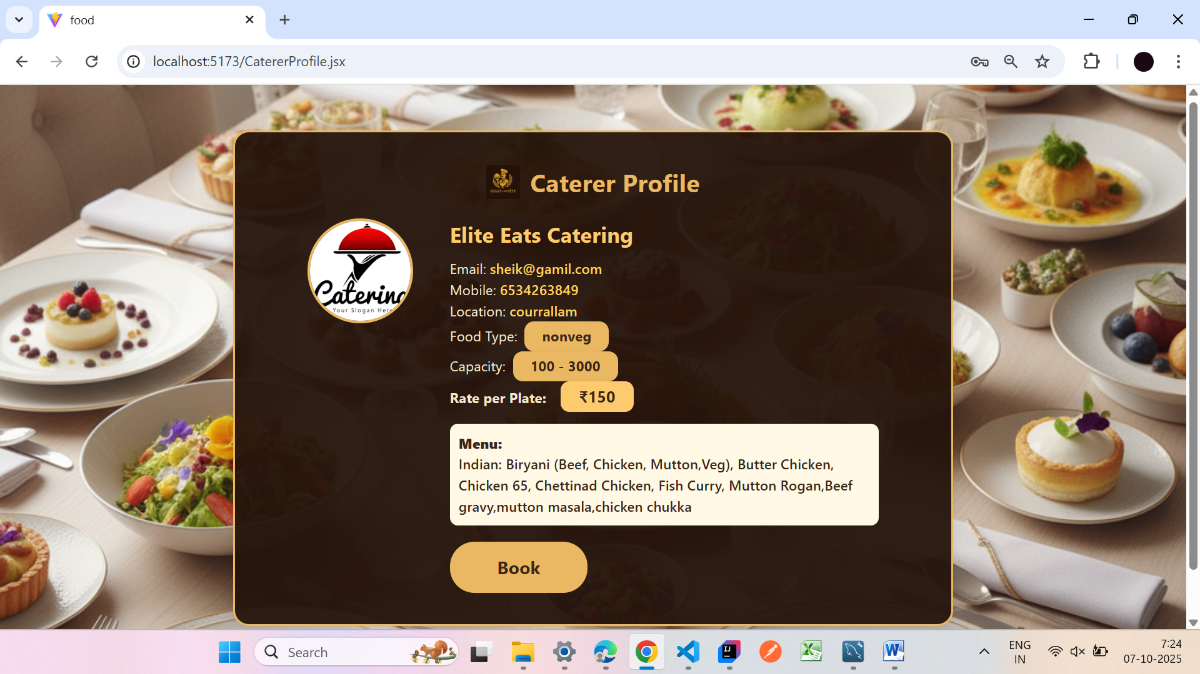

**10.Bill Page;**

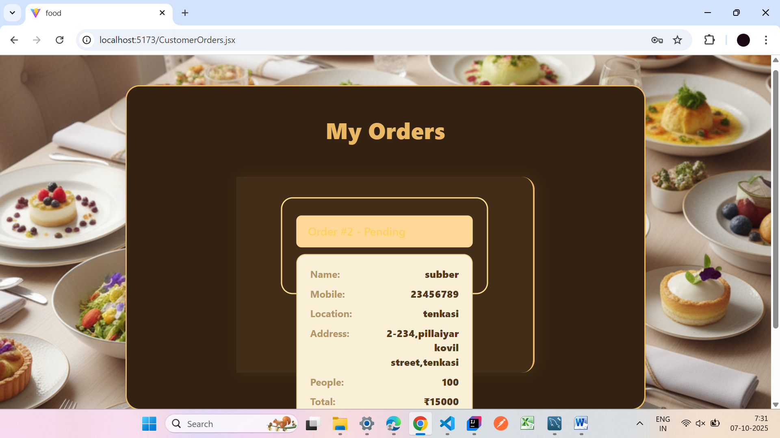

25

**CHAPTER VII**

**SAMPLE CODING**

**1.home.jsx**

import logo from '../img/logo.png'

import "../styles/home.css";

import {useNavigate} from "react-router-dom";

import { FaSearch,FaCalendarAlt,FaTag,FaFacebookF,FaInstagram,FaTwitter } from "react-icons/fa";

function Home() {

const nav = useNavigate();

const gotoregister = () => {

nav("/Registerpage.jsx")

};

const navi = useNavigate();

const gotoownerlogin = () => {

navi("/CustomerLogin.jsx")

};

const navig = useNavigate();

const gotocatererlogin = () => {

navig("/EventOrganizerLogin.jsx")

};

return (

26

<div className="page-root">

<header className="topbar">

<div className="brand">

<img src={logo}></img>

Feast&Fete</div>

<nav className="nav">

<a href="#">About</a>

<a onClick={gotoregister}>Register</a>

<a href="#">Contact</a>

</nav>

</header>

<section

className="hero"

aria-label="Hero - Book caterer"

>

<div className="hero-inner">

<h1 className="hero-titlle">

Book your

<br />

Service Easily

</h1>

<div className="cta-row">

<button className="btns" onClick={gotocatererlogin}>Login as

27

Event Organizer</button>

<button className="btns" onClick={gotoownerlogin}>Login as Customer</button>

</div>

</div>

</section>

<section className="features-wrapper">

<div className="container">

<h2 className="section-titlle">Find Best Caterer</h2>

<div className="features">

<div className="feature">

<div className="icon"><i><FaSearch/></i></div>

<h3>Find Best Caterer</h3>

<p>Search restaurants and caterers by cuisine, ratings and location.</p>

</div>

<div className="feature">

<div className="icon"><i><FaCalendarAlt/></i></div>

<h3>Easy Booking</h3>

<p>Pick a date, choose a package and confirm in a few clicks.</p>

</div>

<div className="feature">

<div className="icon"><i><FaTag/></i></div>

28

<h3>Affordable Packages</h3>

<p>Compare packages and prices to get the best value for your event.</p>

</div>

</div>

</div>

</section>

<footer className="site-footer">

<div className="contact">Contact us</div>

<div className="socials">

<span className="social"><i className="facebook"><FaFacebookF/></i></span>

<span className="social"><i className="instagram"><FaInstagram/></i></span>

<span className="social"><i className="twitter"><FaTwitter/></i></span>

</div>

</footer>

</div>

);

}

export default Home;

29

**2.EventOrganizerRegister.jsx**

import React, { useState } from 'react';

import '../styles/EventOrganizerRegister.css';

import { useNavigate } from "react-router-dom";

import axios from 'axios';

function EventOrganizerRegister() {

const nav = useNavigate();

const [formData, setFormData] = useState({

name: '',

email: '',

password: '',

profilePhoto: null,

menuDetails: '',

mobile: '',

cateringServiceName: '',

foodType: 'both', // veg, nonveg, both

location: '',

maxPeople: '',

minPeople: '',

plateRate: '',

});

const handleChange = (e) => {

const { name, value } = e.target;

30

setFormData(prev => ({

...prev,

[name]: value,

}));

};

const handleFileChange = (e) => {

setFormData(prev => ({

...prev,

profilePhoto: e.target.files[0],

}));

};

const handleSubmit = async (e) => {

e.preventDefault();

if (!formData.name || !formData.email || !formData.password || !formData.mobile || !formData.cateringServiceName) {

alert('Please fill required fields');

return;

}

const postData = {

name: formData.name,

email: formData.email,

password: formData.password,

profilePhoto: formData.profilePhoto ? formData.profilePhoto.name : null,

31

menu: formData.menuDetails,

mobile: formData.mobile,

serviceName: formData.cateringServiceName,

foodType: formData.foodType,

location: formData.location,

maxPeople: formData.maxPeople,

minPeople: formData.minPeople,

plateRate: formData.plateRate,

};

try {

await axios.post('http://localhost:8080/api/organizer/register', postData);

alert('Event Organizer Registered Successfully!');

nav("/EventOrganizerProfile.jsx", { state: { email: formData.email } });

} catch (error) {

alert('Registration failed!');

console.error(error);

}

};

return (

<div className="main">

32

<div className="event-org-container">

<h2>Event Organizer Registration</h2>

<form className="event-org-form" onSubmit={handleSubmit} encType="multipart/form-data">

<input

type="text"

name="name"

placeholder="Name"

value={formData.name}

onChange={handleChange}

/>

<input

type="email"

name="email"

placeholder="Email"

value={formData.email}

onChange={handleChange}

/>

<input

type="password"

name="password"

placeholder="Password"

value={formData.password}

onChange={handleChange}

33

/>

<label className="file-label">

Profile Photo:

<input

type="file"

name="profilePhoto"

accept="image/*"

onChange={handleFileChange}

/>

{formData.profilePhoto && <span>{formData.profilePhoto.name}</span>}

</label>

<textarea

name="menuDetails"

placeholder="Menu Details"

value={formData.menuDetails}

onChange={handleChange}

rows={3}

/>

<input

type="tel"

name="mobile"

placeholder="Mobile Number"

value={formData.mobile}

34

onChange={handleChange}

/>

<input

type="text"

name="cateringServiceName"

placeholder="Catering Service Name"

value={formData.cateringServiceName}

onChange={handleChange}

/>

<select

name="foodType"

value={formData.foodType}

onChange={handleChange}

>

<option value="veg">Veg</option>

<option value="nonveg">Non-Veg</option>

<option value="both">Both</option>

</select>

<select

name="location"

value={formData.location}

onChange={handleChange}

>

35

<option value="">Select Location</option>

<option value="tenkasi">Tenkasi</option>

<option value="shencottai">Shencottai</option>

<option value="vallam">Vallam</option>

<option value="courrallam">Courrallam</option>

<option value="panpoli">Panpoli</option>

<option value="vadakarai">Vadakarai</option>

<option value="idaikal">Idaikal</option>

<option value="kadayanallur">Kadayanallur</option>

<option value="pavoorchathram">Pavoorchathram</option>

</select>

<input

type="number"

name="maxPeople"

placeholder="Maximum People Capacity"

min="1"

value={formData.maxPeople}

onChange={handleChange}

/>

<input

type="number"

name="minPeople"

placeholder="Minimum People Capacity"

36

min="1"

value={formData.minPeople}

onChange={handleChange}

/>

<input

type="number"

name="plateRate"

placeholder="Rate Per Plate (₹)"

min="1"

value={formData.plateRate}

onChange={handleChange}

/>

<button type="submit">Register</button>

</form>

</div>

</div>

);

}

export default EventOrganizerRegister;

**3.CustomerRegister.jsx**

import React, { useState } from 'react';

import { useNavigate } from "react-router-dom";

37

import axios from "axios";

import '../styles/RegisterForm.css';

function CustomerRegister() {

const nav = useNavigate();

const [formData, setFormData] = useState({

name: '',

email: '',

password: '',

mobile: '',

});

const handleChange = (e) => {

const { name, value } = e.target;

setFormData(prev => ({

...prev,

[name]: value,

}));

};

const handleSubmit = async (e) => {

e.preventDefault();

if (!formData.name || !formData.email || !formData.password || !formData.mobile) {

alert('Please fill all fields');

return;

}

38

try {

await axios.post('http://localhost:8080/api/customer/register', formData);

alert('Registration successful!');

// Pass customer email to the next page using React Router state

nav("/CateringServiceList.jsx", { state: { customerEmail: formData.email } });

} catch (error) {

if (

error.response &&

error.response.data &&

error.response.data.message &&

error.response.data.message.includes("already registered")

) {

alert("Email already registered!");

} else {

alert('Registration failed.');

}

console.error(error);

}

};

return (

<div className="main">

<div className="register-container">

39

<h2>Customer Registration</h2>

<form className="register-form" onSubmit={handleSubmit}>

<input type="text" name="name" placeholder="Name" value={formData.name} onChange={handleChange} />

<input type="email" name="email" placeholder="Email" value={formData.email} onChange={handleChange} />

<input type="password" name="password" placeholder="Password" value={formData.password} onChange={handleChange} />

<input type="tel" name="mobile" placeholder="Mobile Number" value={formData.mobile} onChange={handleChange} />

<button type="submit">Register</button>

</form>

</div>

</div>

);

}

export default CustomerRegister;

40

**4.EventOrganizerProfile.jsx**

import React, { useState, useEffect } from 'react';

import '../styles/EventOrganizerProfile.css';

import { useNavigate, useLocation } from "react-router-dom";

import axios from 'axios';

import logo from "../img/logo.png";

function EventOrganizerProfile() {

const nav = useNavigate();

const location = useLocation();

const email = location.state?.email || location.state?.organizerEmail || 'default@email.com';

const orders = () => {

nav("/OrderViewPage.jsx", { state: { email } });

};

const [profile, setProfile] = useState(null);

const [editMode, setEditMode] = useState(false);

const [form, setForm] = useState({});

useEffect(() => {

axios

.get('http://localhost:8080/api/organizer/profile', { params: { email } })

.then(res => {

setProfile(res.data);

setForm(res.data);

console.log(profile.profilePhoto); // Should show "back1.png"

41

});

}, [email]);

const handleEditChange = (e) => {

const { name, value } = e.target;

setForm(prev => ({

...prev,

[name]: value

}));

};

const handleEditSave = async () => {

try {

// Always pass email for backend update

const res = await axios.put(

'http://localhost:8080/api/organizer/profile-edit',

form

);

setProfile(res.data);

setEditMode(false);

} catch (err) {

alert("Profile save failed!");

console.error(err);

}

};

42

if (!profile) return <div>Loading...</div>;

return (

<div className="main">

<div className="profile-main-wrap">

<header className="profile-topbar">

<div className="profile-logo-wrap">

<img src={logo} alt="Logo" className="profile-site-logo"/>

<span className="profile-site-title">Feast & Fete</span>

</div>

<button className="profile-logout-btn">Logout</button>

</header>

<h1 className="profile-page-title">Caterer Profile</h1>

<section className="profile-card">

<div className="profile-row-main">

<img src={`/imgs/${profile.profilePhoto}`} alt="Profile" style={{ width: '150px' }} />

<div className="profile-ids">

<div className="profile-service-name">{profile.serviceName}</div>

<div className="profile-real-name">{profile.name}</div>

<div className="profile-loc">{profile.location}</div>

</div>

<button className="profile-edit-btn" onClick={() => {

43

setForm(profile); setEditMode(true); }}>Edit Profile</button>

</div>

<div className="profile-details-body">

{editMode ? (

<div className="profile-edit-fields">

<label>

Service Name:

<input type="text" name="serviceName" value={form.serviceName || ''} onChange={handleEditChange} />

</label>

<label>

Owner Name:

<input type="text" name="name" value={form.name || ''} onChange={handleEditChange} />

</label>

<label>

Email:

<input type="email" name="email" value={form.email || ''} onChange={handleEditChange} />

</label>

<label>

Mobile Number:

<input type="tel" name="mobile" value={form.mobile || ''} onChange={handleEditChange} />

</label>

44

<label>

Food Type:

<select name="foodType" value={form.foodType || ''} onChange={handleEditChange}>

<option value="Veg">Veg</option>

<option value="Nonveg">Non-Veg</option>

<option value="Both">Both</option>

</select>

</label>

<label>

Location:

<input type="text" name="location" value={form.location || ''} onChange={handleEditChange} />

</label>

<label>

Minimum Capacity:

<input type="number" name="minPeople" value={form.minPeople || ''} min={1} onChange={handleEditChange} />

</label>

<label>

Maximum Capacity:

<input type="number" name="maxPeople" value={form.maxPeople || ''} min={1} onChange={handleEditChange} />

</label>

<label>

45

Menu Details:

<textarea name="menu" value={form.menu || ''} rows={3} onChange={handleEditChange} />

</label>

<div style={{marginTop:12}}>

<button className="profile-edit-btn" onClick={handleEditSave} type="button">Save</button>

<button className="profile-cancel-btn" onClick={() => setEditMode(false)} type="button">Cancel</button>

</div>

</div>

) : (

<div className="profile-details-list">

<div><span>Email:</span> {profile.email}</div>

<div><span>Mobile:</span> {profile.mobile}</div>

<div><span>Food Type:</span> {profile.foodType}</div>

<div><span>Location:</span> {profile.location}</div>

<div><span>Capacity:</span> {profile.minPeople} - {profile.maxPeople} people</div>

<div>

<span>Menu:</span> {profile.menu}

</div>

</div>

)}

</div>

46

</section>

<div style={{ marginTop: '28px', textAlign: 'center' }}>

<button className="profile-orders-btn" onClick={orders}>

Orders

</button>

</div>

</div>

</div>

);

}

export default EventOrganizerProfile;

5**.CatringServiceList.jsx**

import React, { useEffect, useState } from "react";

import "../styles/CateringServiceList.css";

import { useNavigate, useLocation } from "react-router-dom";

import axios from "axios";

function CateringServiceList() {

const nav = useNavigate();

const location = useLocation();

const customerEmail = location.state?.customerEmail;

const [services, setServices] = useState([]);

useEffect(() => {

axios

.get("http://localhost:8080/api/organizer/list")

.then((res) => setServices(res.data))

.catch((err) => {

setServices([]);

47

console.error(err);

});

}, []);

const catresh = (service) => {

nav("/CatererProfile.jsx", { state: { serviceId: service.id, customerEmail } });

};

const goToOrders = () => {

nav("/CustomerOrders.jsx", { state: { customerEmail } });

};

return (

<div className="catering-list-bg">

<div className="catering-list-header">

<div className="catering-list-title">Catering Services</div>

<button className="orders-btn" onClick={goToOrders}>

Orders

</button>

</div>

<div className="catering-grid">

{services.map((service) => (

<div

className="catering-card"

key={service.id}

onClick={() => catresh(service)}

>

<div className="catering-img-wrap">

<img

src={

service.profilePhoto

? `/imgs/${service.profilePhoto}`

: "/imgs/default-profile.png"

}

alt={service.serviceName}

/>

</div>

48

<div className="catering-card-details">

<div className="catering-card-name">{service.serviceName}</div>

<div className="catering-card-location">{service.location}</div>

</div>

</div>

))}

</div>

</div>

);

}

export default CateringServiceList;

**6.BillPage.jsx**

import React, { useState } from 'react';

import '../styles/BillPage.css';

import { useNavigate, useLocation } from "react-router-dom";

import axios from "axios";

function BillPage() {

const location = useLocation();

const nav = useNavigate();

const {

email = '',

plateRate = 200,

peopleCount = 250,

customerEmail = ''

} = location.state || {};

const [name, setName] = useState('');

const [mobile, setMobile] = useState('');

const [locationField, setLocationField] = useState('');

const [address, setAddress] = useState('');

const [date, setDate] = useState('');

49

const [mealTimes, setMealTimes] = useState([]);

const mealOptions = ["Morning", "Afternoon", "Evening", "Dinner"];

const totalAmount = peopleCount * plateRate;

const advanceAmount = Math.round(totalAmount * 0.4);

const handleMealChange = (meal) => {

setMealTimes((prev) =>

prev.includes(meal)

? prev.filter(m => m !== meal)

: [...prev, meal]

);

};

const handleBook = async (e) => {

e.preventDefault();

if (!name || !mobile || !locationField || !address || !date || mealTimes.length === 0) {

alert('Please fill all required fields and select at least one meal time.');

return;

}

try {

await axios.post('http://localhost:8080/api/booking/create', {

catererEmail: email,

customerEmail,

customerName: name,

customerMobile: mobile,

customerLocation: locationField,

customerAddress: address,

numberOfPeople: peopleCount,

plateRate: plateRate,

totalAmount: totalAmount,

advanceAmount: advanceAmount,

status: 'pending',

bookingDate: date,

mealTimes: mealTimes.join(',')

});

50

alert(`Order placed!\nCaterer Email: ${email}\nCustomer Email: ${customerEmail}\nTotal: ₹${totalAmount}\nAdvance: ₹${advanceAmount}`);

nav("/CateringServiceList.jsx", { state: { customerEmail } });

} catch (err) {

alert('Booking failed!');

console.error(err);

}

};

return (

<div className="main">

<div className="bill-container">

<header className="bill-header">

<h2>Catering Bill Summary</h2>

</header>

<form className="bill-main bill-form" onSubmit={handleBook}>

<div className="user-details">

<input

type="text"

name="name"

placeholder="Name"

value={name}

onChange={e => setName(e.target.value)}

required

/>

<input

type="tel"

name="mobile"

placeholder="Mobile Number"

value={mobile}

onChange={e => setMobile(e.target.value)}

required

/>

<input

type="text"

51

name="location"

placeholder="Location"

value={locationField}

onChange={e => setLocationField(e.target.value)}

required

/>

<textarea

name="address"

placeholder="Address"

value={address}

onChange={e => setAddress(e.target.value)}

rows={2}

required

/>

<input

type="date"

name="date"

value={date}

onChange={e => setDate(e.target.value)}

className="input-date"

required

/>

<div className="meal-times-group">

<label className="input-label">Meal Times:</label>

<div className="meal-options">

{mealOptions.map(meal => (

<label key={meal} className="meal-checkbox-label">

<input

type="checkbox"

checked={mealTimes.includes(meal)}

onChange={() => handleMealChange(meal)}

className="meal-checkbox"

/>

<span className="meal-checkbox-text">{meal}</span>

</label>

52

))}

</div>

</div>

</div>

<div className="bill-details">

<div className="people-fixed">

Number of People: <span className="fixed-value">{peopleCount}</span>

</div>

<div className="rate-summary">

<span>Per Plate Rate:</span> <span className="plate-rate">₹{plateRate}</span>

</div>

<div className="total-summary">

<span>Total Bill:</span> <span className="total-amount">₹{totalAmount}</span>

</div>

<div className="advance-summary">

<span>Advance (40%):</span> <span className="advance-amount">₹{advanceAmount}</span>

</div>

<div className="notice">

Order placed! The catering service will contact for advance payment (40% of total).

</div>

<button className="book-btn" type="submit">Book Now</button>

</div>

</form>

</div>

</div>

);

export default BillPage;

53